B. Tech PROJECT SUMMARY (MPS) SHEET
Title of project: Disease Prediction of Crops using IoT

Name of the Supervisor: Prof. P.T. Sawant
Name of the Students:
- Nilesh V. Pingale (Roll No.1654005)
- Vaishnavi V. Tevare (Roll No. 1654012)

Ananya V. Malwade (Roll No. 1654013)
- Shubham S. Yadav (Roll No. 1404044)
Brief description:
India is an agricultural country which fully depends on agriculture, agricultural production and crops for its economic survival. Agriculture is the major source of India. The agriculture production will play an important role in the development of the country. Due to GDP will get improve by the agriculture production. With help of technological involvement and its usability still have to be grown and cultivated for agriculture sector in India.
IOT is an emerging technology all over the world and it is used in agriculture for monitoring different parameters. The Internet of Things (IOT) has the capability to automatically transform the world. we all use application and live in the application of technology IOT in agriculture could have the strong impact on agricultural productivity.
Finally, we analyze the feasibility of disease prevention mechanism based on the use of IOT for farmers in developing countries.
The farmers face lot of problems in the crops due to the diseases. Major problems in the agriculture include water problem, climatic change, pests and diseases in the plants.
In IOT-based smart farming, a system is built for monitoring the crop yield with the help of sensors (light, humidity, temperature, soil moisture, etc.) and automating the irrigation system. The farmers can monitor the yield conditions from anywhere. IOT-based farming is highly smart and efficient when compared with the conventional approach.
1. Monitoring the current atmospheric condition
2.Setup our module with program.
3.What’s app message send to the Farmer mobile number
4.Sensor active 24*7 for monitoring weather and atmospheric condition.
5.If weather Condition is not suitable for crops, then our system will sense abnormal conditions itself and farmer will get notify about it and this will lead to prevent future loss.
6.Notification is done via WhatsApp Message service.
Objectives:
- To identify and prevent disease depending on environmental condition.
- To prevent Economical loss by knowing uncertainty in atmosphere.
- To notify farmer by sending WhatsApp alert if any unfavourable condition occurs.
- Maximize the farmer production.
Outcomes:
- Sponsorship letter
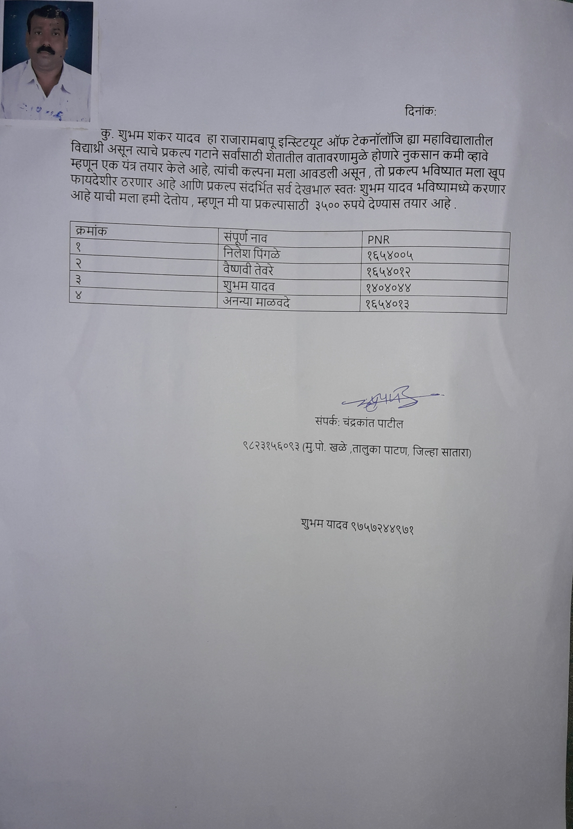
- New research methodology details (New algorithm/implementation)
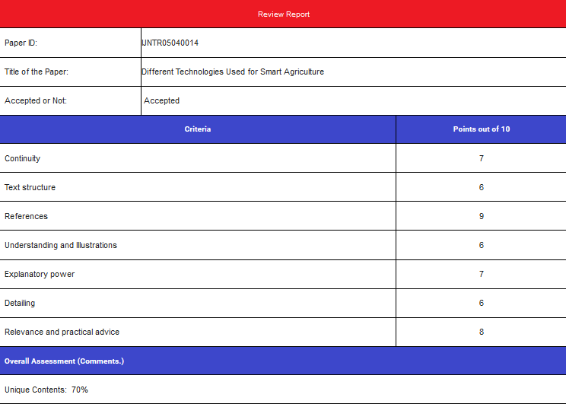
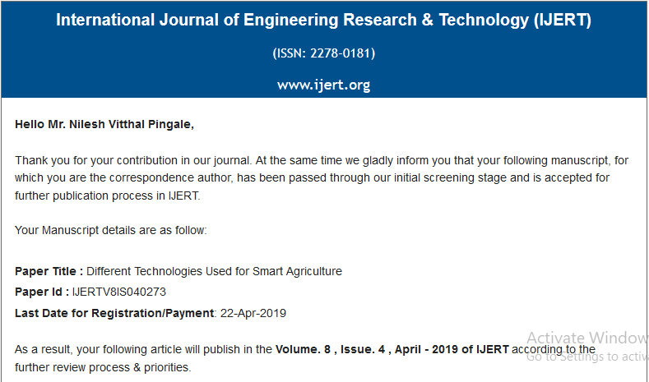

Photograph of Working Model:
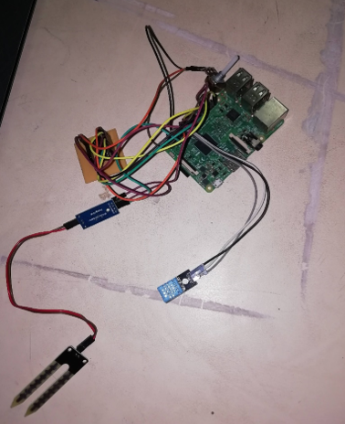

Signature of Supervisor/s: __________________________________________________

